A writing prompt
When working on narrative writing, I use either a picture (see Figure 1 for an example) or a short video that is very thought provoking and requires using the imagination to determine what is happening. I have found David Zinn’s street art to be particularly powerful in the upper primary grades. I also use short animation videos available from DreamWorks and Pixar on YouTube (see https://www.youtube.com/watch?v=D0a0aNqTehM for an example).

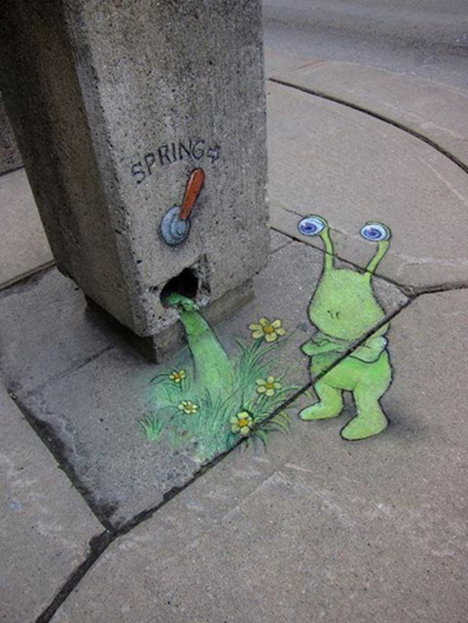

The prompt is viewed together as a whole class, and I then facilitate a whole-class brainstorm where students share what they think was happening in the picture or video, and what they could write about in a narrative. After 5-10 minutes of whole-class brainstorming, students are given 60 minutes to plan, draft, revise and edit a narrative using the prompt as a basis.
I aim to get all pieces marked within 48 hours, and then discuss and share feedback with each student in a 1:1 conference within a week of the test being completed. This enables the student to engage in assessment as learning and identify a personal learning goal for the unit

